CI/CD Deployment for Spring boot Application Screenshots.

Contents

1. Image 1: 2

2. Image 2: 2

3. Image 3: 3

4. Image 4: 3

5. Image 5: 4

6. Image 6: 4

7. Image 7: 5

8. Image 8: 5

9. Image 9: 6

10. Image 10: 6

11. Image 11: 7

12. Image 12: 7

13. Image 13: 8

14. Image 14: 8

15. Image 15 9

16. Image 16: 10

17. Image 17: 10

18. Image 18: 11

# Image 1:

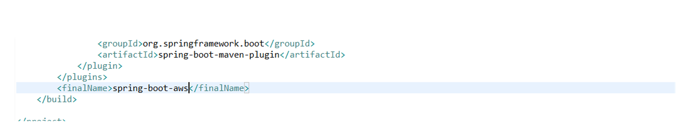

# Image 2:

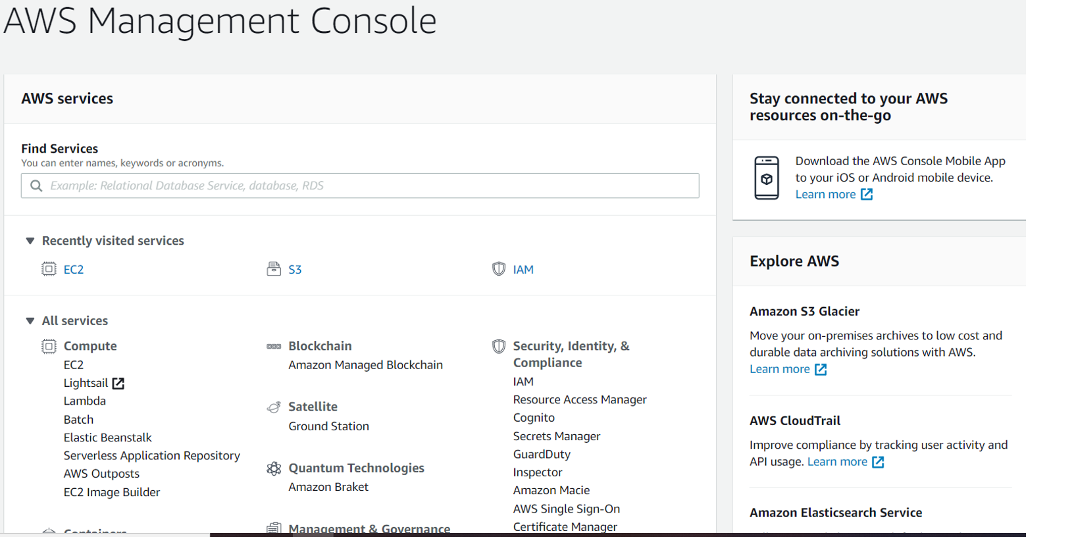

# Image 3:

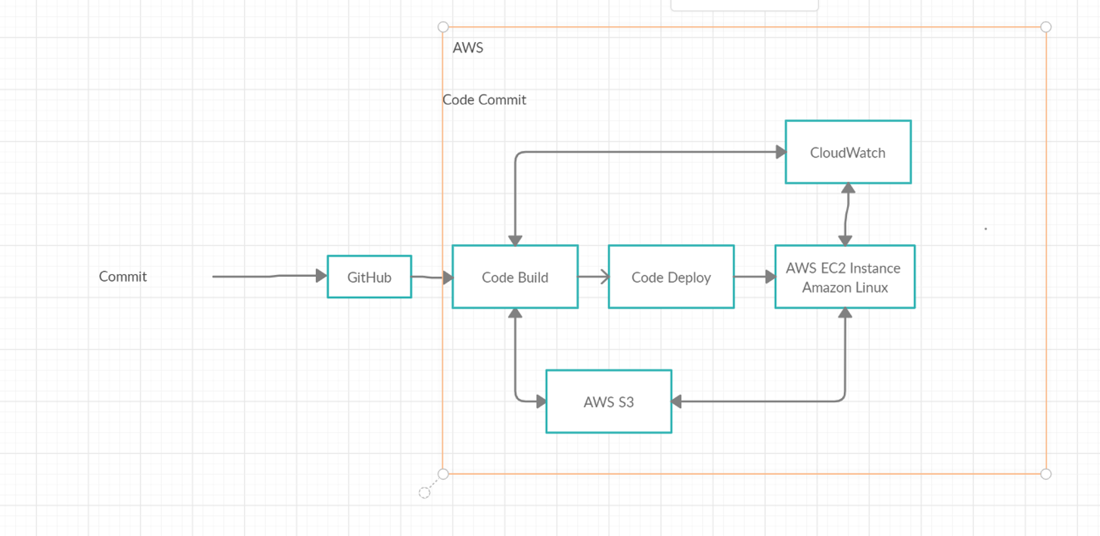

# Image 4:

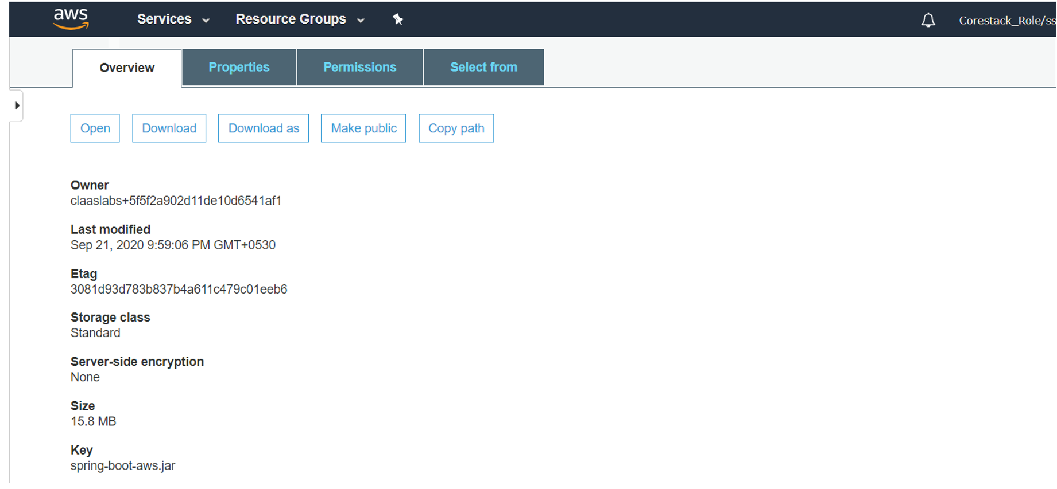

# Image 5:

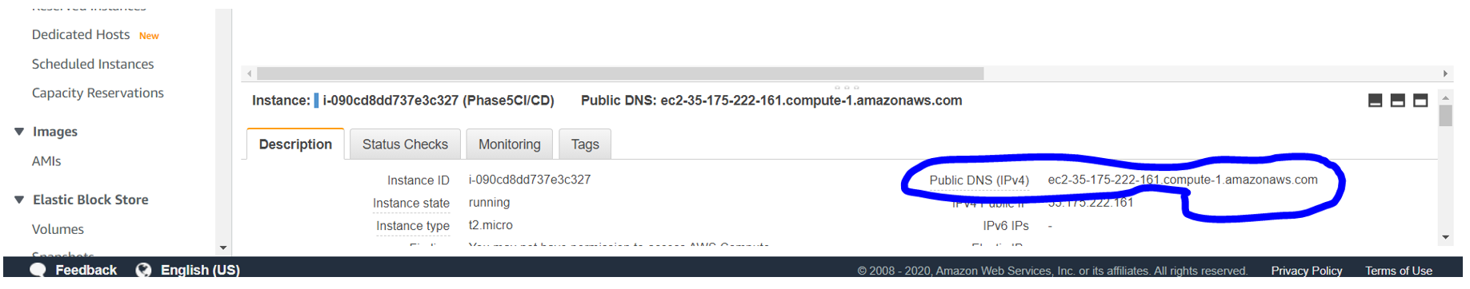

# Image 6:

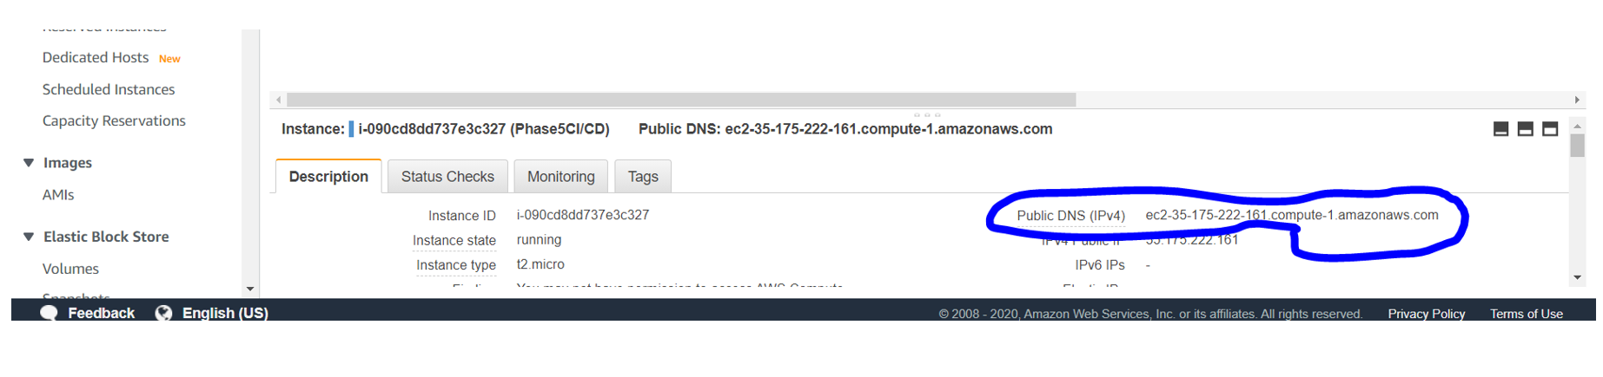

# Image 7:

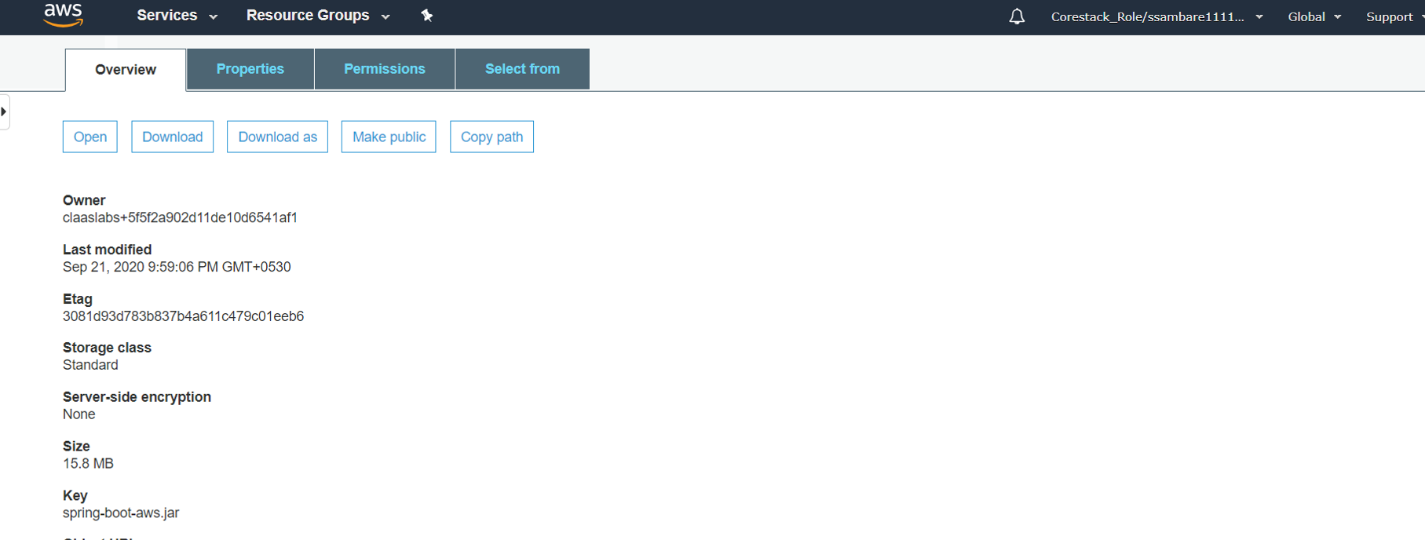

# Image 8:

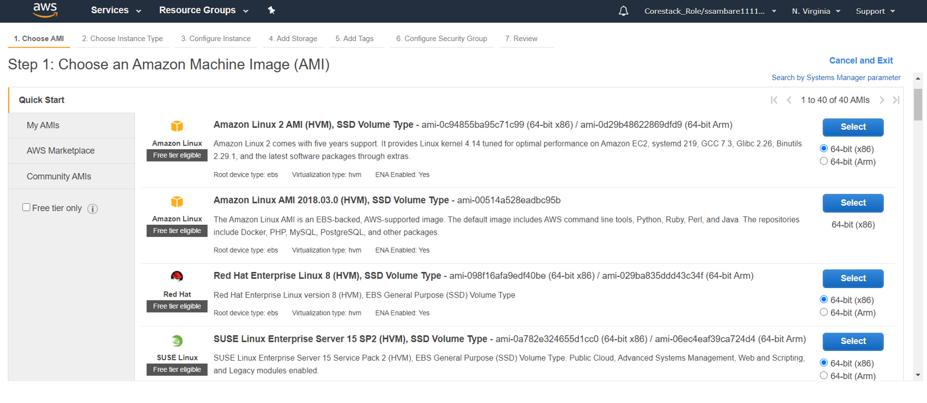

# Image 9:

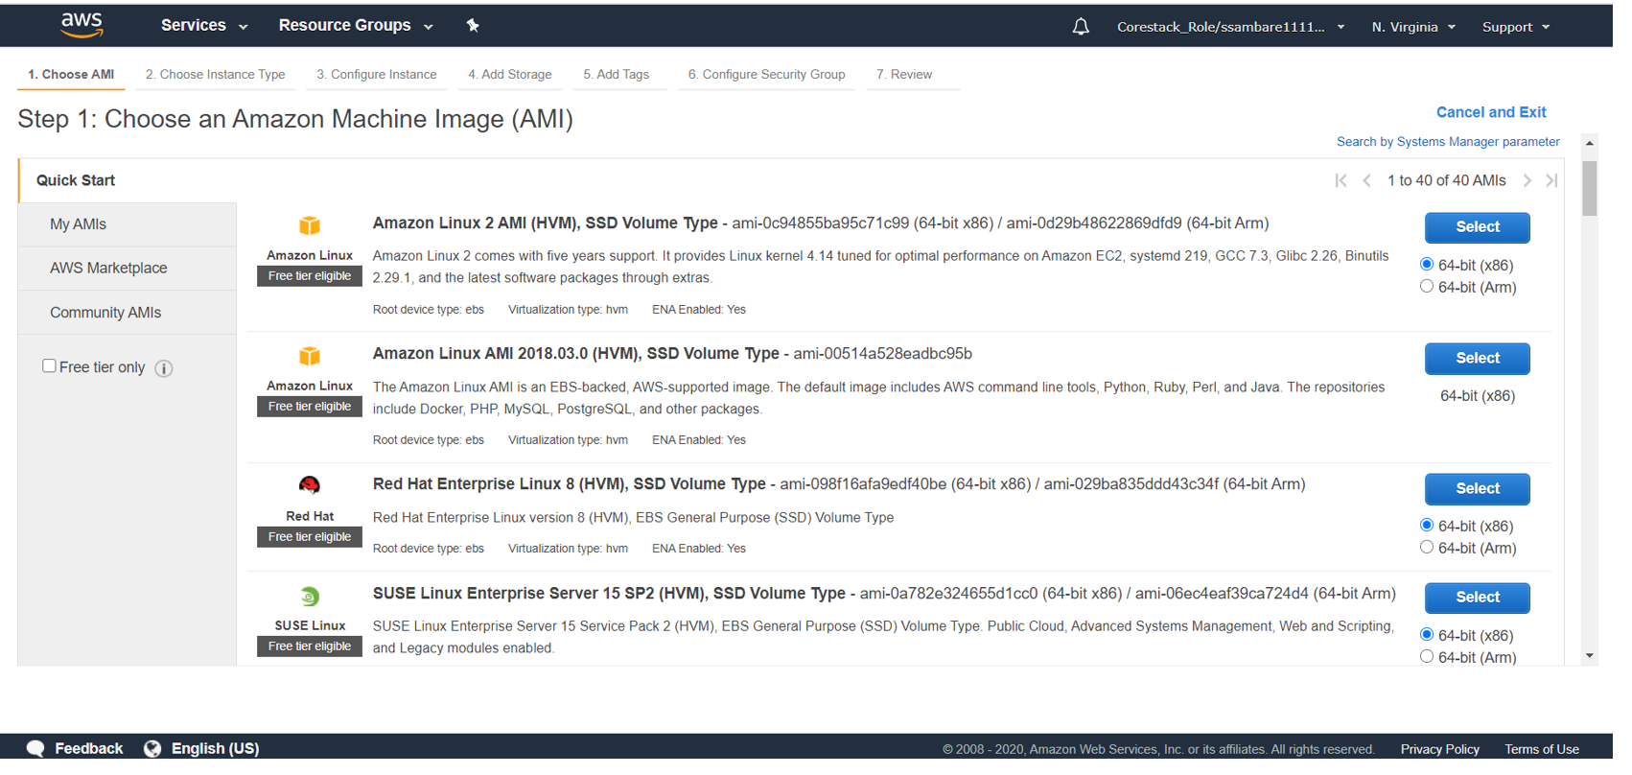

# Image 10:

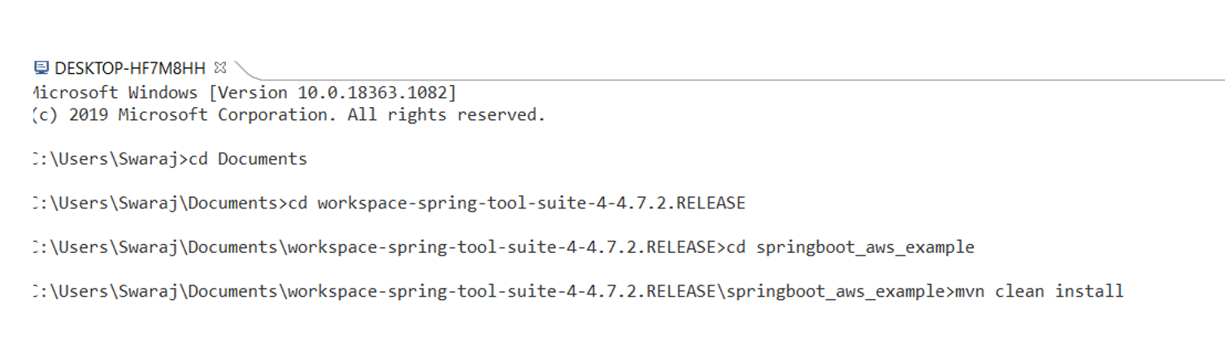

# Image 11:

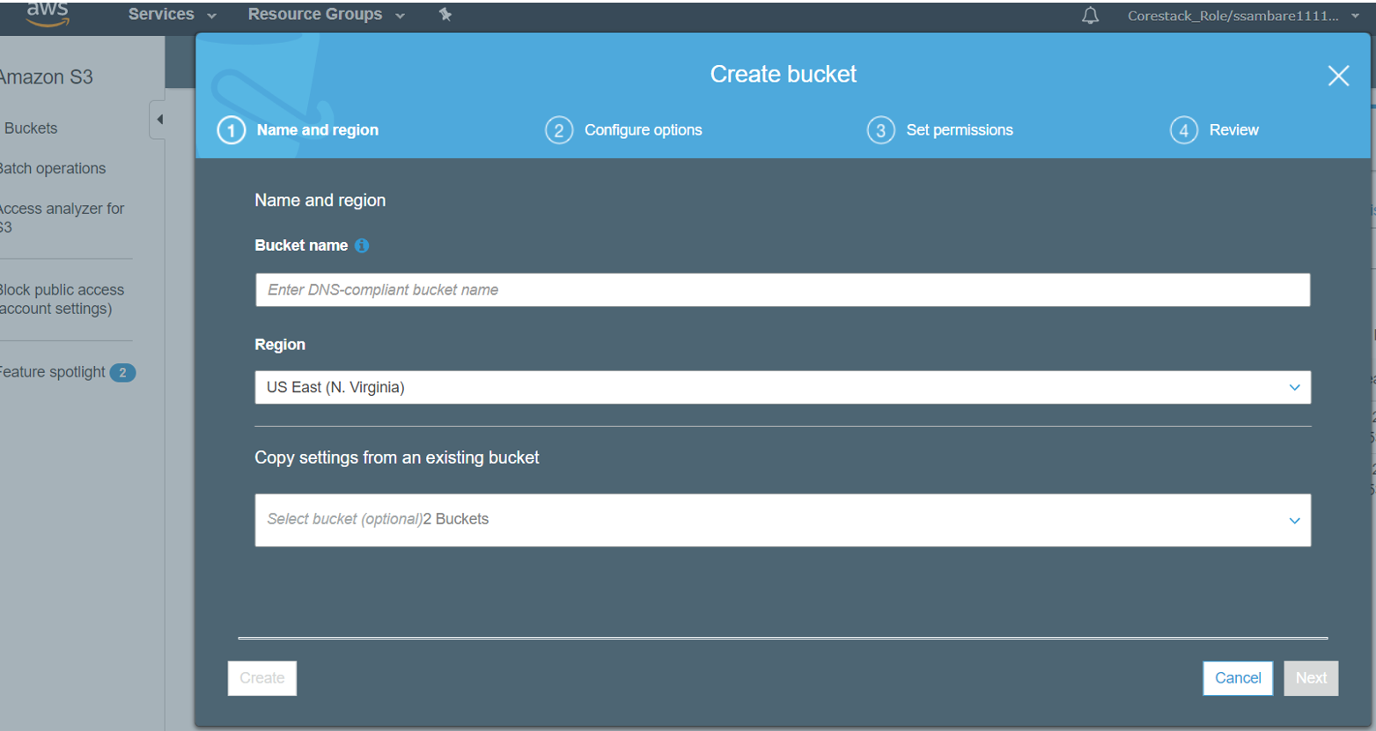

# Image 12:

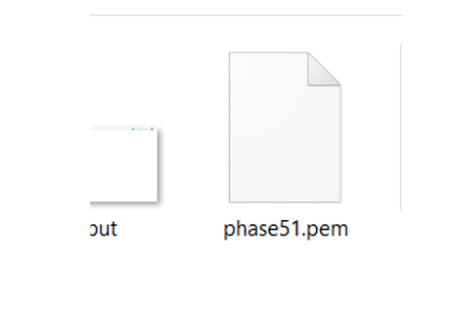

# Image 13:

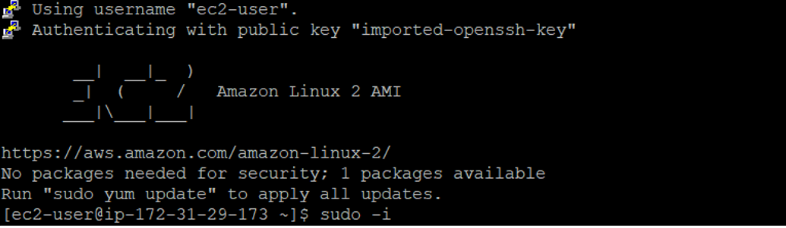

# Image 14:

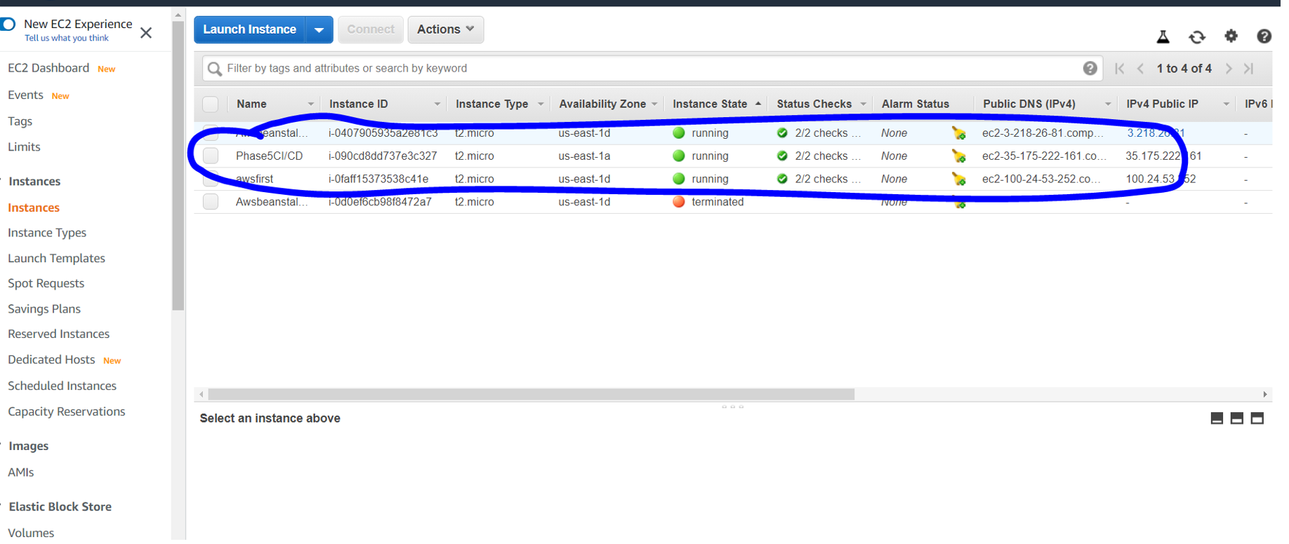

# Image 15

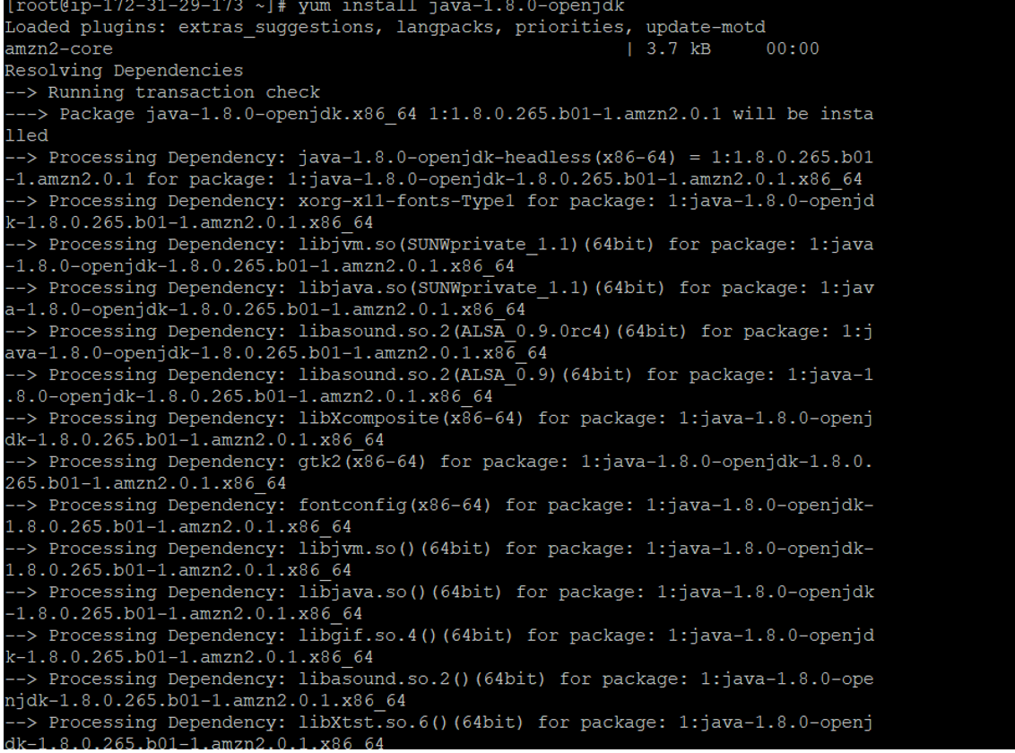

# Image 16:

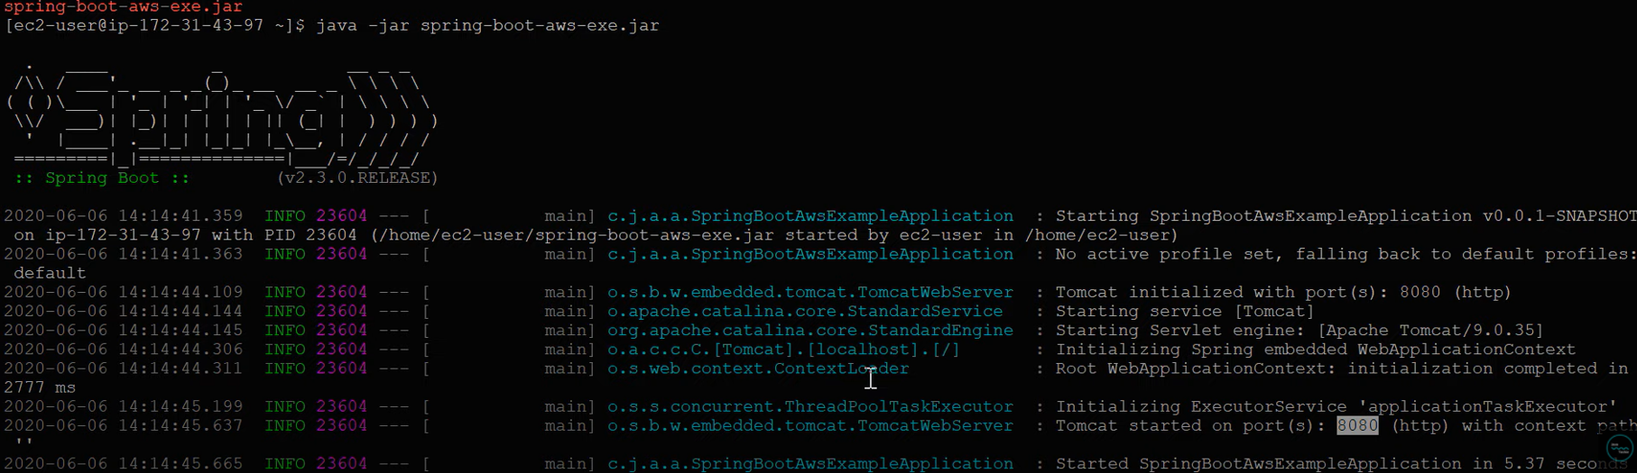

# Image 17:

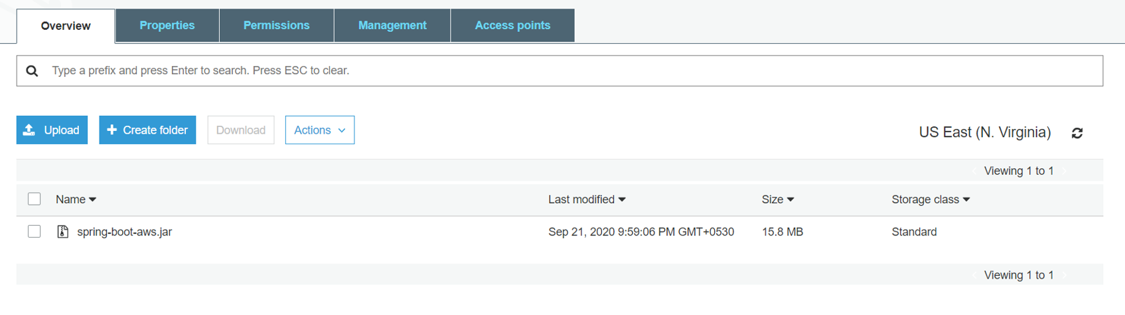

# Image 18:

